Lab Program 2:

Develop a Java program to create a class Student with members usn, name, an array credits and an array marks. Include methods to accept and display details and a method to calculate SGPA of a student.

CODE:

import java.util.*;

class Student{

String usn;

String name;

int credits[] = new int[10];

int marks[] = new int[10];

int total_credits = 0;

int sum = 0;

int i;

double SGPA;

void initialize(String usn, String name)

{

this.usn = usn;

this.name = name;

}

void display()

{

System.out.println("The name of the student is: " + name);

System.out.println("The usn of the student is: " + usn);

}

void calculate(int credits[],int marks[],int n)

{

for(i = 0;i<n;i++)

{

total_credits+=credits[i];

if(marks[i] > 89)

{

sum+=credits[i]*10;

}

if(marks[i] > 79 && marks[i] < 90)

{

sum+=credits[i]*9;

}

if(marks[i] > 69 && marks[i] < 80)

{

sum+=credits[i]*8;

}

if(marks[i] > 59 && marks[i] < 70)

{

sum+=credits[i]*7;

}

if(marks[i] > 54 && marks[i] < 60)

{

sum+=credits[i]*6;

}

if(marks[i] > 49 && marks[i] < 55)

{

sum+=credits[i]*5;

}

if(marks[i] > 39 && marks[i] < 50)

{

sum+=credits[i]*4;

}

}

System.out.println("Total credits in this course is " + total_credits);

System.out.println("sum of grade points multiplied by credis is " + sum);

SGPA = (double)sum/total_credits;

System.out.println("SGPA is " + SGPA);

}

}

class Main

{

public static void main(String args[])

{

int i,n;

String name,usn;

int credits[] = new int[10];

int marks[] = new int[10];

Scanner sc = new Scanner(System.in);

System.out.println("Enter your name:");

name = sc.next();

System.out.println("Enter your USN: ");

usn = sc.next();

System.out.println("Enter number of courses");

n = sc.nextInt();

System.out.println("Enter marks");

for(i=0;i<n;i++)

{

marks[i] = sc.nextInt();

}

System.out.println("Enter the credits");

for(i=0;i<n;i++)

{

credits[i] = sc.nextInt();

}

Student s1 = new Student();

s1.initialize(name,usn);

s1.display();

s1.calculate(credits,marks,n);

}

}

WRITTEN CODE:

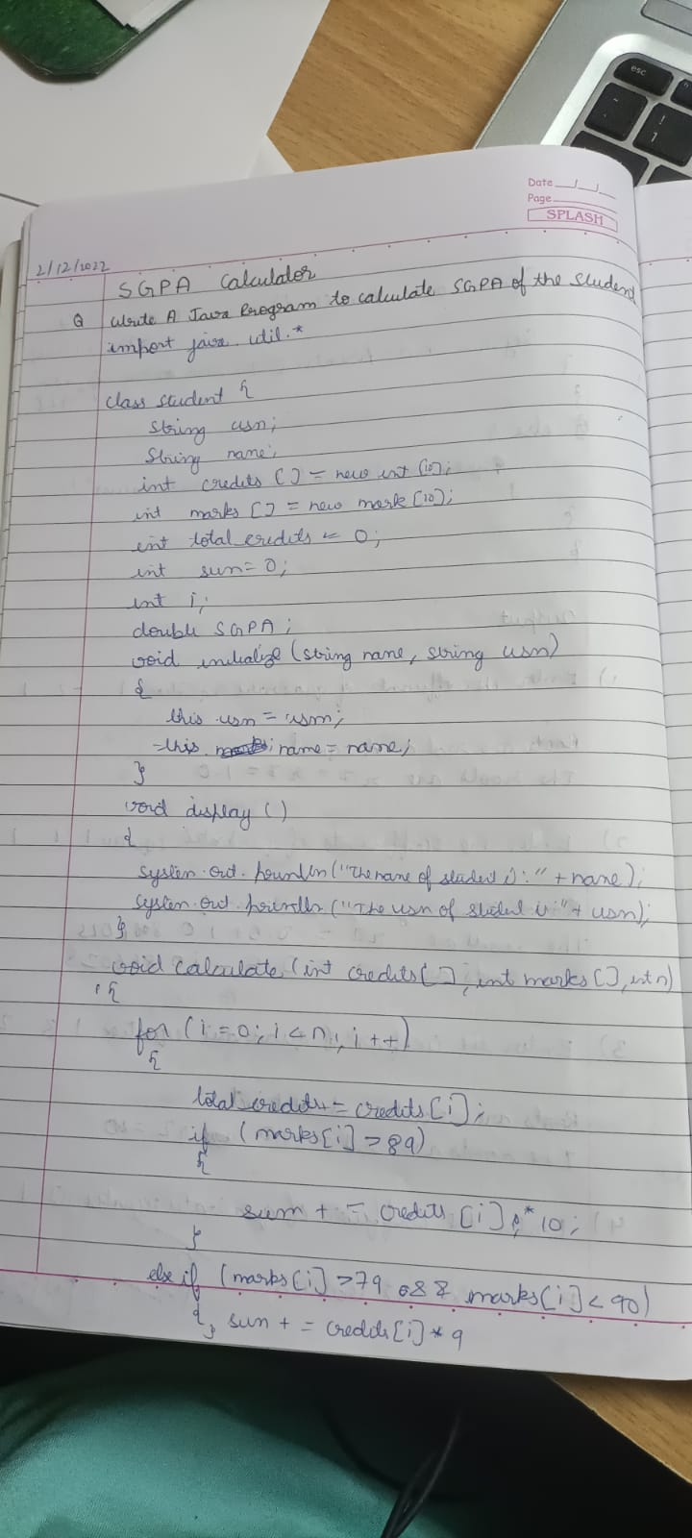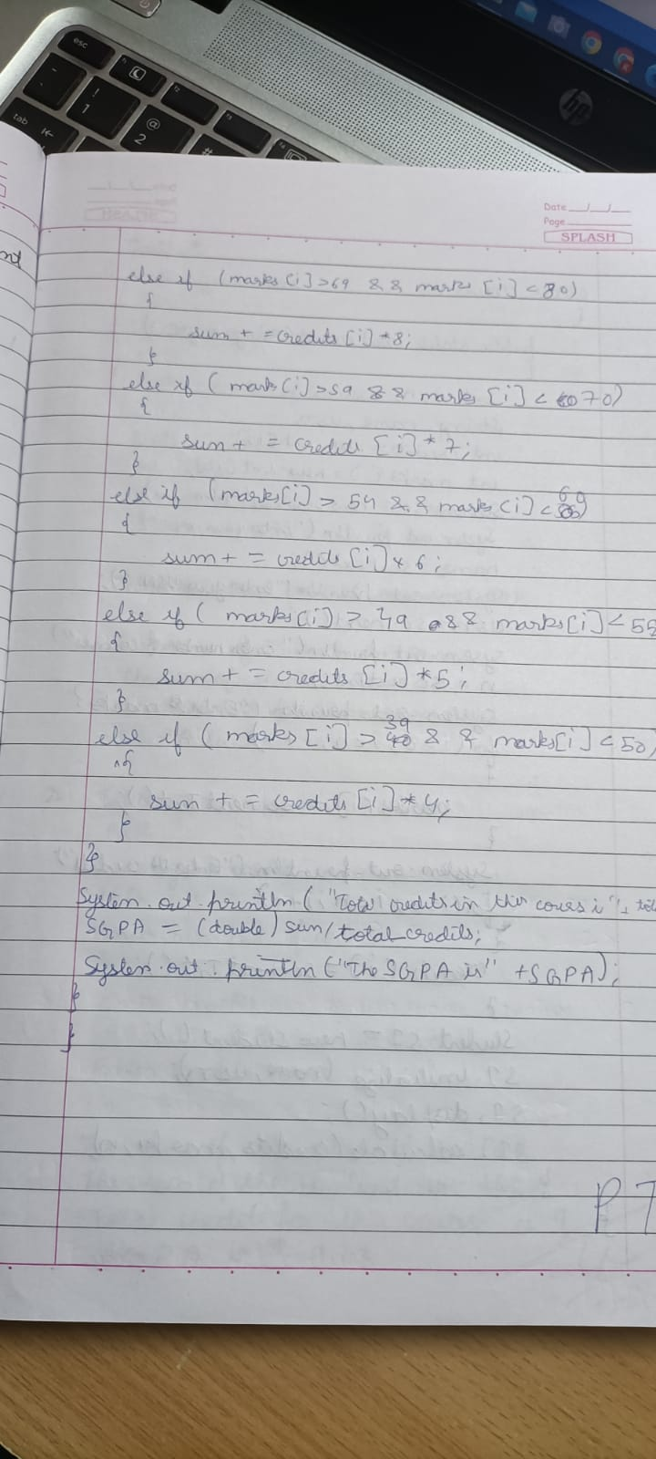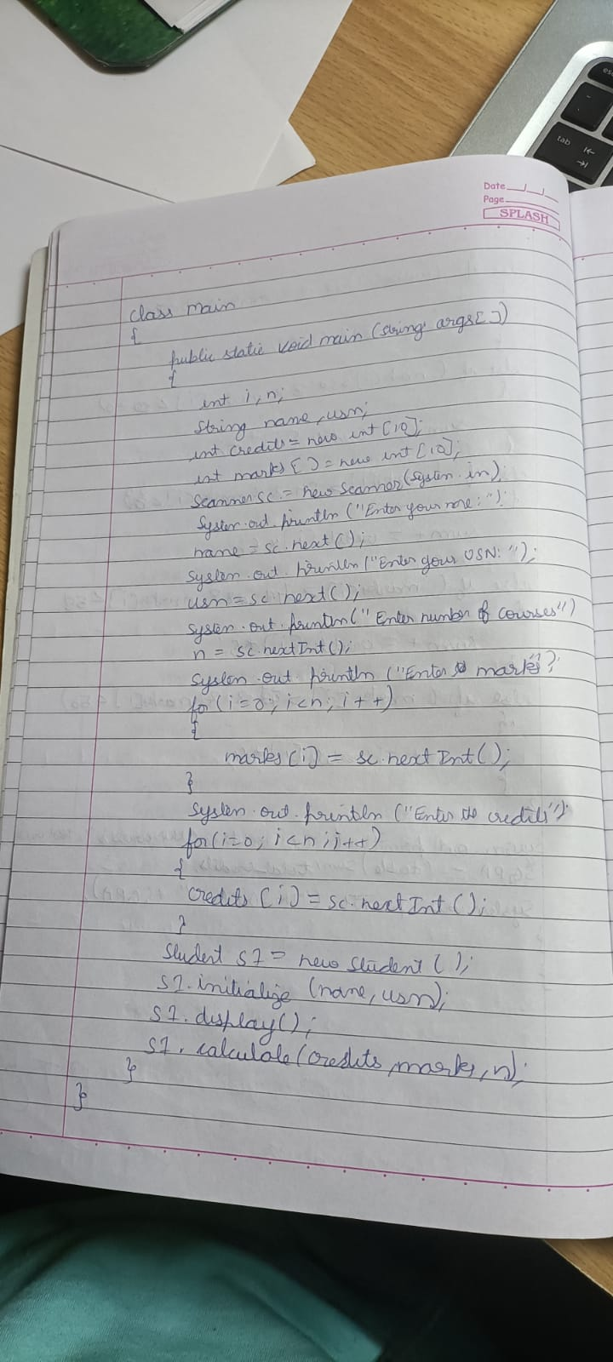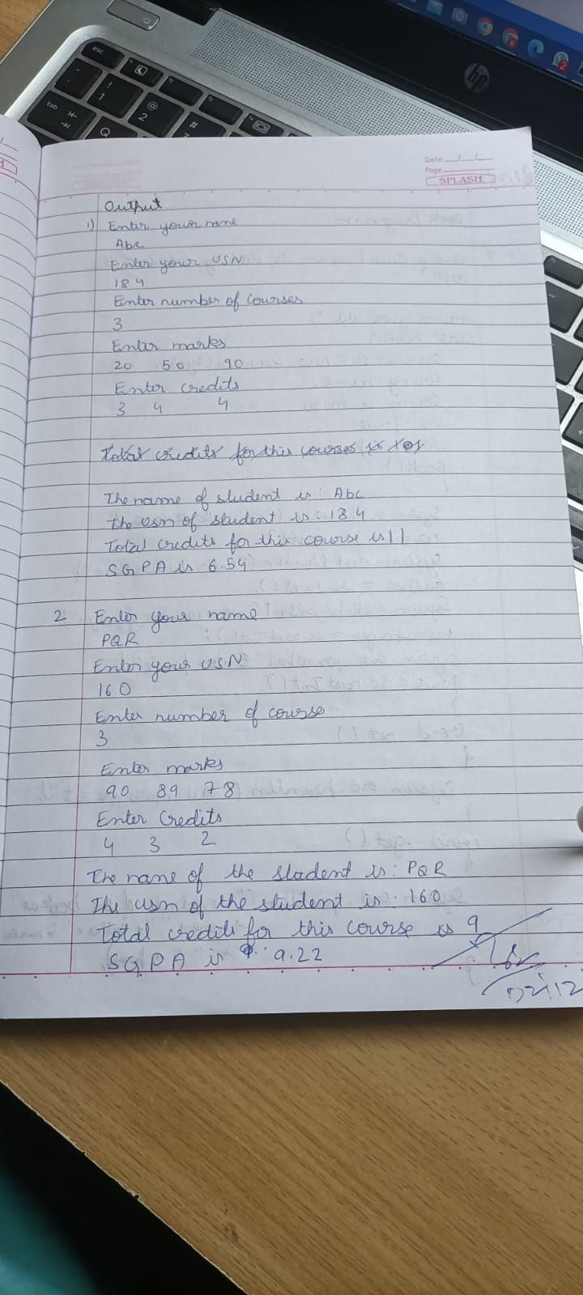

OUTPUT:

